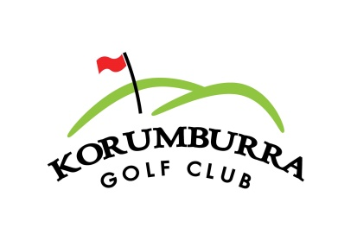
Junior Golf Clinics:
Date: Saturday 13th Oct – Saturday 1st Dec.
or
Date: Sunday 14th Oct – Sunday 2nd Dec.
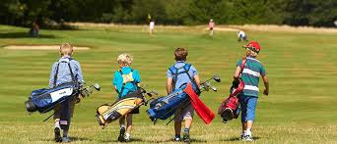
From: 10 - 11pm
8 Sessions – Cost $80
(50% off if Junior Member or sign up as one: $50)
- From Beginners to Intermediate. (Ages 6-17)
- Clubs provided.
- Fun and inviting.
- Includes playing on course.
For reservations please call John Payne,
PGA Golf Professional.
0491 115 962

